Zen class table

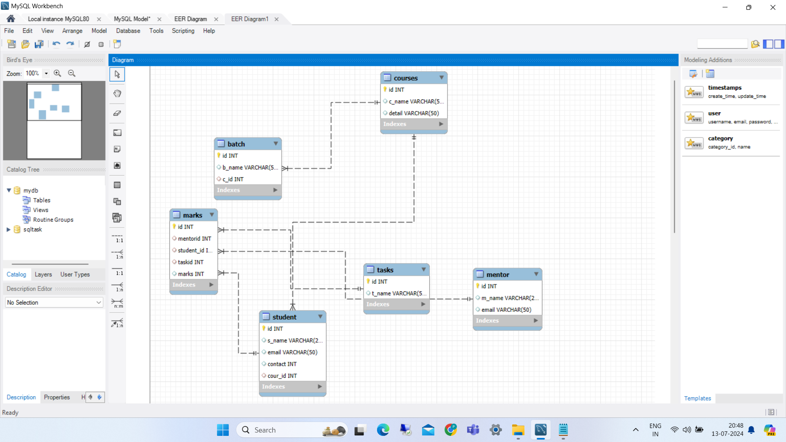

create table mentor(id int primary key,m_name varchar(25),email varchar(50));

describe mentor;

insert into mentor (id,m_name,email)values

(100,"PugazharasanC","pugazh@abc.com"),

(102,"Sathish","sathish@abc.com"),

(103,"sureshbabu","suresh@abc.com");

select * from mentor;

create table courses(id int primary key,c_name varchar(50) ,detail varchar(50));

describe courses;

insert into courses(id,c_name,detail)values

(21,"fullstack","javascript,html,css,react,db"),

(22,"Datascience","The study of data"),

(23,"Artificial intelligence","How computer things like people"),

(24,"Cryptography","Security authentication of computer");

select * from courses;

create table student(id int primary key,s_name varchar(25),email varchar(50),contact int,

cour_id int,foreign key(cour_id) references courses(id));

describe student;

insert into student (id,s_name,email,contact,cour_id)values(1,"Prema","prem@abc.com",98754,21),

(2,"Hema","hema@abc.com",89765,22),

(3,"Krishnaveni","veni@abc.com",789654,24),

(4,"bala","bala@abc.com",86673,23),

(5,"venkat","venkat@abc.com",908765,21);

select* from student;

create table tasks (id int primary key,t_name varchar(50));

describe tasks;

insert into tasks(id,t_name)values

(21,"dom"),

(22,"promise"),

(23,"pagination"),

(24,"reactcard"),

(25,"Sql");

select* from tasks;

create table batch(id int primary key,

b_name varchar(50) ,c_id int,foreign key(c_id)references courses(id));

describe batch;

insert into batch(id,b_name,c_id)values

(1001,"fsd13wd",22),

(1002,"ds23we",21),

(1003,"ai54wd",23),

(1004,"cg78we",21);

select *from courses;

create table marks(id int primary key,mentorid int ,foreign key(mentorid) references mentor(id), student_id int,foreign key(student_id)references student(id),

taskid int,foreign key(taskid)references tasks(id),marks int);

describe marks;

insert into marks(id,mentorid,student_id,taskid,marks)values

(10001,100,1,21,70),

(10002,103,3,22,80),

(10003,102,2,23,60),

(10004,103,4,24,90);

select * from marks;